Deadline: February 15, 2017
This form is to be used to nominate a candidate to the Kansas Teachers’ Hall of Fame. In order to be eligible, the nominated candidate must have been a certified K-12 teacher or administrator for at least 25 years in the state of Kansas.

Date Submitted:________________

Nominee’s Name: _______________________________________________________

Mailing Address: _______________________________________________________
(Street) (City) (Zip)
Telephone Number: ( ) County: _________________

Email address: _________________________________________________________

Total Kansas teaching service: ____years.

Current Teaching Status: Active __ Retired __ If retired, what year? __________

School District: _____________________________ (If more than one, select a preferred school district.)

Hometown Newspaper:_________________________________________________________

Contact information for person submitting this nomination. (This cannot be a relative of the nominee.)

Name: ________________________________________ Telephone: (____)______________

Address: ____________________________________________________________________
(Street) (City) (Zip)

Email address: _______________________________________________________________

Information to be submitted
Submit only the information requested. Additional or missing information, letters, photos, etc. will invalidate the nomination.
- Nomination form.
- A photo of the nominee.
- The nominee’s educational goals and teaching philosophy. (200 words or less, written by the nominee.)
- Number of years of Kansas teaching experience. Please specify each location, subject(s) taught and number of years at each location.
- Awards, honors positions, and recognitions (civic, school, college, church, etc.)
- Educational background, including college/university, degree(s), and dates, as well as significant professional growth activities.
- Community involvement and/or service to the teaching profession.
- Characteristics that set this nominee apart from the other nominees.
- Five (5) letters of recommendation. At least one letter must be from a former student, one from a fellow teacher, with the remaining three letters of recommendation as the nominator wishes.

All nomination materials must be submitted in the order listed above, on one-sided documents, using no smaller than 12 point font. Each item should be no more than a single page in length, unstapled, unbound, and copy-ready. Nominations will remain active for three years.

The First Teachers Hall of Fame in the United States

The Kansas Teachers’ Hall of Fame

Nomination Form
Mail completed application to:

Kansas Teachers’
Hall of Fame
P.O. Box 1674
Dodge City, KS 67801

Officers:
President
Kathy Frederking
Dodge City
Vice-President
Marilyn Davidson
Hays
Secretary
Mary Lou Doris
Dodge City
Treasurer
Patricia Kolb,
Dodge City
USD 443 Superintendent
Alan Cunningham
Dodge City

District Heads:
#1 Jannette Luthi
Madison
#2 Dr. Roger Caswell
Emporia
#3 Robert Hottman
Harper
#4 Pam Taverner
Wichita
#5 Debi Ellis
Hutchinson
#6 Martha Pfannenstiel
Dodge City
#7 Leanna Wylie
Quinter
#8 Harvey Davidson
Hays
#9 Kenneth Trickle
Salina
#10 Roger Brannan
Manhattan
#11 Nancy Musselman
Silver Lake
#12 John McDonald
Stilwell

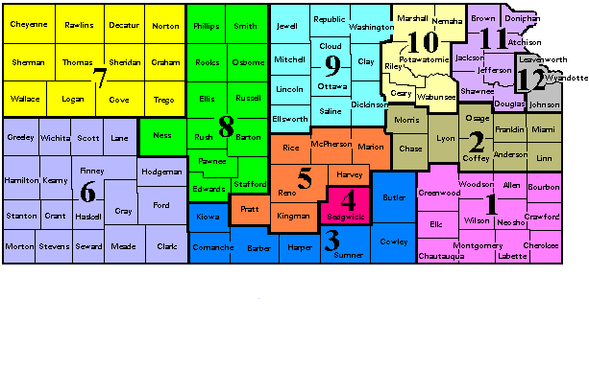

District Heads

- Jannette Luthi, 2352 360th St, Madison, KS 66860
jannette@cableone.net 620-332-7754
- Dr. Roger Caswell, 1623 Berkeley, Emporia, KS 66801
rcaswell@emporia.edu 620-341-5372
- Robert Hottman, 103 West 8th, Harper, KS 67058
bob_hottman@hotmail.com 620-896-2575
- Pam Taverner, 1551 N. Fairview Ave, Wichita, KS 67203
pam.taverner@knea.org 316-253-2503
- Debi Ellis, 1004 31st Terrace, Hutchinson, KS 67502
dellis48@cox.net 620-663-7418
- Martha Pfannenstiel, 2407 4th Circle, Dodge City, KS 67801
mar-bob@cox.net 620-227-8838
- Leanna Wylie, 612 Park Street, Quinter, KS 67752
leannawylie@gmail.com 785-754-8146
- Harvey Davidson, 2716 Thunderbird Drive, Hays, KS 67601
mariharv@ruraltel.net 785-628-8951
- Kenneth Trickle, 2136 Hillside Drive, Salina, KS 67401
cumc09@sbcglobal.net 785-827-7634
10. Roger Brannan, 3448 Treesmill Drive, Manhattan, KS 66503
rbrannan@kansas.net 785-539-5163
11. Nancy Musselman, 303 Falcon Court, Silver Lake, KS 66539
nemusselman@gmail.com 785-582-4789
12. John McDonald, 5675 W. 194th St, Stilwell, KS 66085
mjandjmcdonald@sbcglobal.net 913-897-4214

